ITEM PF11

PENSION FUND COMMITTEE – 29 AUGUST 2003

HEDGE FUNDS

Report by the Head of Finance and the Independent Financial Adviser

- It is recommended that this report should be considered in conjunction with the attached paper (Annex 1) ‘Hedge Funds Made Simple’ published in 2001 by the National Association of Pension Funds.

Origin of Hedge Funds

- The original concept of hedge funds was devised by Alfred Winslow Jones. He was born in 1900 and had a varied career – Harvard 1923, ship’s purser on a passenger liner for 10 years, vice consul in the US embassy in Berlin, studied for a doctorate in sociology at Colombia University, then associate editor of Fortune magazine. In 1948, while researching for an article on forecasting stockmarket trends, virtually all the professionals he interviewed said it was impossible to forecast the direction of the market with any degree of consistency. Jones then developed the idea of generating market profits while attempting to eliminate market risk. His method was to buy undervalued stocks and sell short over valued stocks (i.e. stocks he did not own, but borrowed). The basket of stocks sold short was an insurance or hedge against a fall in the market. He also borrowed (leveraged) to increase the size of the total portfolio and so hopefully enhance returns.

Distinguishing Features of Hedge Funds

- The principal distinguishing features between normal investment funds, such as pensions funds, and hedge funds are as follows:

  - Pension funds and similar investment funds are:

    - Long only funds i.e. they buy and hold shares and bonds, but they do not sell shares and bonds they do not own by borrowing such securities.

    - They aim to achieve performance relative to an index or benchmark i.e. if their chosen index rises by 10% they aim to outperform by rising by more than 10% or if it falls by 10% they aim to decline by less than 10%.

    - They do not normally leverage i.e. borrow to invest in more shares or bonds than their total resources would otherwise permit.

    - They make only limited use of derivatives (futures, options etc.) and such use is normally restricted to asset allocation, cash flow management and currency hedging.

  - Hedge Funds’ distinguishing features are:

    - They aim to produce absolute returns, that is always positive returns, and not relative returns to an index which may go down as well as up.

    - They are not just long only funds. Many of their strategies involve short selling, that is selling securities they do not own, making delivery by borrowing the necessary stock.

    - They frequently leverage, that is borrow to invest more than their assets would otherwise permit, and sometimes borrow substantially in relation to their total assets.

    - They make wide use of derivatives.

    - Funds following particular strategies may invest in assets not normally held by pension funds such as distressed debt, commodities, corporate bonds below investment grade, bonds of companies in difficulties or even defaulted sovereign debt (countries that have defaulted).

- Hedge funds have experienced enormous growth over the thirteen years since 1990 as the following chart shows, with total assets worldwide estimated to have increased from around £40 billion in 1990 to over £600 billion by end 2002 and with the number of funds to have risen from some 600 to over 5000 worldwide.

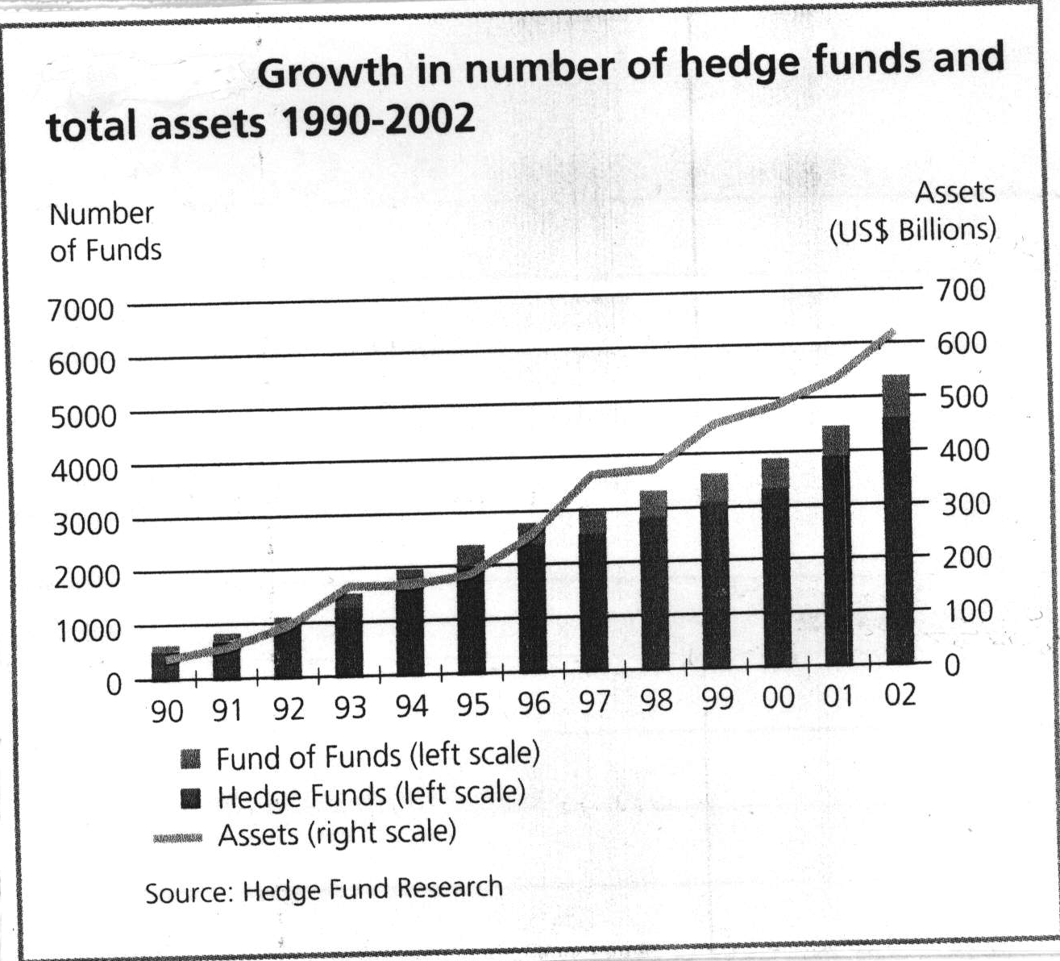

Hedge Fund Strategies

- Within the total hedge fund industry, individual funds tend to follow specific strategies. These strategies may be broadly summarised as follows:

  - Non-directional Strategies

They do not depend on the direction of any broad market movement and are usually referred to as ‘market neutral’ strategies. They are designed to exploit short term market inefficiencies or pricing discrepancies of securities, currencies or commodities. There are several sub-strategies within the broad generic category of ‘market neutral’ strategies. The principal ones are listed below:

    - Equity Market Neutral, where a fund has offsetting long and short positions in different shares, where the manager aims to profit from both rises and falls in the price of securities. Leverage (borrowing) is frequently used.

    - Fixed Income Arbitrage

Similar to i) above but in fixed incomes securities, and also exploiting anomalies occurring to maturity and credit rating. Derivatives and leverage are also used.

    - Event Driven strategy that aims to benefit from mispricing arising during mergers, takeovers etc.

    - Restructuring, which is a strategy of buying and shorting the whole range of securities from senior debt to ordinary shares of companies undergoing some form of reorganisation, including the liquidation of financially distressed companies.

    - Convertible Arbitrage which is a strategy of buying and selling different securities of the same issuer (e.g. convertibles and ordinary shares) seeking to exploit price anomalies.

  - Directional Strategies

These hope to benefit in some degree from broad market movements. Some of the popular directional strategies are:

    - Equity long/short also known as Equity Hedge (Long Bias). This employs a strategy of investing in equity or equity like instruments where the net exposure (long minus short) is often significantly long. Derivatives and leverage are often employed.

    - Global Macro which is a strategy of long and short positions in the world’s major markets (securities, commodities, currencies and interest rates). Again derivatives and leverage are employed.

    - Dedicated Short Bias is a strategy that sells securities short in the hope of repurchasing them in the future at a lower price.

Benefits of Investing in Hedge Funds

- There are two principal benefits for a pension fund of investing in hedge funds:

  - The reduction of risk

Hedge funds aim to deliver absolute rather than relative returns in contrast to pension funds which normally seek to produce returns relative to a chosen benchmark. Further, hedge funds are either not correlated or only correlated to a certain extent to stock markets (see 5 above). (Funds of hedge funds correlation to stock markets is around 0.4). These two factors help to reduce risk in a portfolio.

  - The reduction of volatility

The factors in a) above also help to reduce the volatility of returns produced by pension funds.

- Hedge Fund Performance

The hedge fund industry has produced consistent returns over the past decade as the following figures which are net of management fees show:

 | Annualised Returns to  31 December % |  |  |  | Annual Returns to 31December 2002 %
 | 2000 | 2001 | 2002 |  | 3 year | 5 year | 10 year
HFR Fund Weighted Composite* | 5.0 | 4.6 | - 1.5 | 2.7 |  | 7.8 | 13.1
HFR Fund of Funds Index * | 5.0 | 2.8 | 1.0 | 2.7 |  | 5.3 | 8.8
FTSE All Share Index | - 5.9 | - 13.3 | - 22.7 | - 14.2 |  | - 2.3 | 6.8
US S&P 500 Index | - 10.1 | - 13.0 | - 23.4 | - 15.7 |  | - 1.9 | 7.3
Cash (7 day LIBID) | 5.7 | 4.8 | 3.7 | 4.7 |  | 5.3 | 5.6
* Source: Hedge Fund Research

- The figures for hedge fund performance need to be read with slight caution as they are modestly inflated by ‘survivorship’, in that they do not include funds that cease trading each year, generally because they are too small to be viable longer term, but there are also a very few funds which have been wiped out. Further, hedge funds tend to perform better in sideways or falling markets and perform less well in strong bull markets, even under performing long only funds such as pension funds. If looking ahead security markets are going to be more pedestrian, as seems probable, this could be an added advantage to a pension fund investing in hedge funds.

Regulation and Risk

- Most hedge funds are based in low or no tax centres, which means the regulation of funds tends to be light if there is any at all. However, most of the fund managers operate from the major financial centres where there is regulation of their other activities. Even so there is a lack of transparency in most hedge funds. The details of funds strategies are complex and managers are reluctant to reveal much about their investment process. Further managers will not disclose their recent activity to the ordinary investor because of the competitive disadvantage this might entail. However, the lack of regulation and transparency is balanced by the fact that most hedge fund managers are acutely aware of risk, generally far more so than long only managers probably because of the level of risk they are taking and so seek to control it rigorously. In fact whereas the risk on long only funds is largely to market movements, the risk in hedge funds is in the quality of the manager.

Selection of Suitable Hedge Funds

- How then should pension funds invest in hedge funds? The ideal would be to invest directly in a portfolio of top performing hedge funds with a diversity of strategies, as Oxfordshire currently does with private equity, but there are problems with this approach. The lack of transparency makes it difficult to gain detailed knowledge of such funds; hedge funds depend on the skill of individual managers, who are not so available and open as long only investment managers; many of the better hedge funds are closed to new subscription; when invested in a fund, liquidity can be a problem, with a long delay in redemption; style drift does occur – one may have invested in a fund with a particular strategy, but over time a manager may gradually change his strategy unbeknown to the ordinary institutional investor; and now with over 5000 hedge funds in existence the sheer size of the problem in selecting the best funds with a spread of strategies, at the same time not ignoring new ones with very able managers, is obviously huge.

Fund of Funds

- The obvious route is to invest in a fund of funds managed by a reputable house. They will have a large team of analysts constantly researching hedge funds and their managers. They will select the best, with a spread of strategies, continually monitor their activities (fund of funds have the muscle to demand the necessary information) and managers watch for style drift, frequently have the ability to buy into ‘closed’ funds, dispose of under performing funds or funds subject to ‘style drift’ and will provide liquidity if one wishes to exit. One cannot just buy and hold an individual hedge fund. There are nevertheless disadvantages to fund of funds in that there is still some measure of lack of transparency and there is a double fee structure.

- Fees

  - Hedge funds levy a flat management fee of around 1 ½%pa, together with a ‘carry’ or performance fee of about 20% of the gain achieved over a hurdle rate of return, which may be an absolute 7%-8%, or the US Treasury Bill rate or the Standard & Poors (S & P) Common Stock Index. The performance fee is also normally subject to ‘high water mark’, which means that any losses in previous periods must be recovered before the hurdle rate is applied and so before any performance fee becomes due.

  - In addition, funds of funds charge flat fees of about 1% pa, plus a performance fee of around 10% of the out performance over a hurdle rate of return and, as with the underlying hedge funds, subject to high ‘water mark’.

This double layer of fees, both of which are much higher than long only pension fund managers charge, may seem excessive, but if viewed against the performance achieved, particularly against a bear market such as the last three years, almost make the fees seem trivial. Moreover, the selection of quality funds of hedge funds should place performance in the top two quartiles, if not higher and so improve on the performance of the index shown in the table in paragraph 7.

Way Ahead

- If it is accepted that the fund of funds route is the logical one for a pension fund investing a modest proportion of total assets in hedge funds, there is still the problem of selecting the fund of funds in which to invest. There are now over 500 funds of hedge funds worldwide, managing up to 25% of the whole hedge fund universe and inevitably the consistency of their performance varies. Oxfordshire has recently appointed UBS Global Asset Management, a very reputable house, to manage a multi asset inclusive of property portfolio. Within the UBS overall group they have a sister company O’Connor, which manages funds of hedge funds, but more importantly there is another company in the group, UBS Wealth Management. This company manages the assets of substantial private individuals, who have been the leading major investors in hedge funds. UBS Wealth Management have some £20 billion invested in hedge funds on behalf of clients, much of this in funds of funds. They do not just use O’Connor vehicles, but also those managed by other reputable houses in order to obtain diversification of performance and also of style, since even funds of funds do differ in style, with greater emphasis on some strategies than others. Any investment by the Oxfordshire Pension Fund in hedge funds should be spread between two or possibly three fund of funds, probably chosen from those managed by O’Connor, Martello (non UBS), GAM (Global Asset Management, acquired by UBS in December 1999) and one or two other houses among others. Although UBS Wealth Management normally only act for substantial private investors, they would be prepared to advise and act for the Oxfordshire Pension Fund. They would obtain their fee by a rebate from the funds of funds in which the pension fund invested. Officers and the independent financial adviser would have detailed discussions with UBS Wealth Management and seek to meet the managers of the funds of funds selected.

RECOMMENDATIONS

- The Committee is RECOMMENDED that:

        - 2% of the Pension Fund’s assets be invested in hedge funds in line with the customised benchmark;

        - this investment be made through two or three funds of hedge funds;

        - the officers, in consultation with the Independent Financial Adviser be authorised to select the funds of funds, make the investment and report action taken to the 21 November 2003 meeting; and;

        - UBS Wealth Management be retained to advise and act on behalf of the Pension Fund.

CHRIS GRAY A F BUSHELL
Head of Finance Independent Financial Adviser

August 2003

Contact Officer: Tony Wheeler, Pension Fund Investments Manager. Tel (01865) 815287

Background Papers: Nil

August 2003

